Credentialing System Capstone Project

Stefana Rusu

Devon Fairman

Tyler Palmer

Davenport University

**Table of Contents**

Introduction 3

Definition, Description, Background 3

Purpose of the Report and Intended Audience 3

Scope of the Inquiry/ Deliverables 4

Methods of Inquiry 4

Project Risks/Limitations 5

Team Qualifications 7

System 7

Database 7

ERD 8

Use Cases 8

MVC 10

Client Side 10

Testing 10

Testing Plan 10

Feedback 11

Conclusion 11

Appendix A: SWOT Analysis 13

Appendix B: Relevant Figures 15

Credentialing System Capstone Project

**Introduction**

**Definition, Description, Background**

This program will implement a credentialing system for Davenport University that will store the requirements for a course regarding instructor credentials, room equipment, room software, location requirements, and other relevant constraints that pertain to the scheduling of a course. Davenport University currently uses various spreadsheets and local folders to maintain instructor credentials and potential schedules. The main goal of this system is to create a more efficient way of maintaining those credentials.

Due to certain constraints such as time, resources, and experience, the team is not able to see this project to completion. Although the team members have conducted thorough research on topics such as MVC, Bootstrap, SQL, and JQuery, the team is far from being proficient with these tools. The project will inevitably be delayed (meaning that a future team of developers will need to continue the project). Although this risk of scheduling and estimation could not be mitigated it can be minimized. The current team will create a deployment plan which will contain information on how to smoothly transition the next team to take over the project.

**Purpose of the Report and Intended Audience**

The scope of the project is to design and implement the aforementioned credentialing system to reflect the approved use cases. The purpose of this project is to create a more efficient way of tracking instructor credentials and determining which instructors are qualified to teach specific courses.

The primary stakeholder who would be benefiting from the results of this project would be the scheduling department. This credentialing system should handle credentialing for all departments, except for Occupational Therapy, College of Health, and any Online classes. The project has various constraints and risks that are mentioned throughout this report.

**Scope of the Inquiry/ Deliverables**

The main purpose of the project is to provide a more efficient way of tracking instructor credentials and schedules for the Davenport University Scheduling Department. The team has designed and implemented the database using SQL Server 2012. For the future, the project should allow the possibility of Oracle work for access to course-related data from the Davenport University Banner.

The team has also utilized Visual Studio 2017 to develop an MVC Web Application (.NET Framework 4.6.1) using C#. The MVC application utilizes Bootstrap 4.x and JQuery 3.X on the client side. The MVC application will not be completed, but it will be partly functional.

The deliverables for the project are:

* Database (tables, stored procedures and relationships)
* MVC Application (partly functional and successfully connects/ makes changes to the database)
* Technical Documentation (thorough details so that other teams can pick up the project in future Capstone classes)
* Testing Plan
* Deployment Plan
* Project Report & Presentation

**Methods of Inquiry**

The team has conducted thorough research in order to design and implement the credentialing system. The project manager has overseen project requirements elicitation by conducting meeting with the stakeholders and communicating with them via email. Other materials have been used to conduct research into MVC, SQL, and Bootstrap.

**Project Risks/Limitations**

The project has encountered various risks and limitations that needed to be mitigated. The most pressing ones are listed below. These risks describe not only how the project is affected, but also how the team members are affected.

* **Estimation and Scheduling (Critical).** The team is unfamiliar with the APIs and frameworks. This lack of experience has the potential to influence the schedule. To mitigate this risk, the team is conducting research using lynda.com and Microsoft channel 9 into JQuery, Bootstrap, and MVC. Although the team has conducted thorough research on the required topics, the team is far from being proficient with the tools. This will cause the project to be delayed (meaning that a future team of developers will need to continue the project). This risk cannot be mitigated; however, it can be minimized. The current team will create a transition plan to ensure a smooth transition for the next team.
* **Sudden Growth in Requirements.** Without a thorough understanding of the requirements, issues can arise as the deadline approaches. This risk was mitigated by interviewing stakeholders and performing a SWOT analysis to gather requirements (see Appendix A).
* **Breakdown of Specification (Critical).** Requirements can end up conflicting with one another. This risk should be avoided by having the whole team at stakeholder meetings, so those that would be implementing the specifications can ask questions to better understand the specifications.
* **Productivity Issues**. Developers tend to underestimate longer projects early on. This should be mitigated somewhat by the team’s experience during the internship working on a larger project.
* **Compromising on Designs**. Designs are often rushed to get to the actual coding phase of the project. The risk will be avoided by conducting the research to understand requirements and the team working to create a thorough design.
* **Gold Plating.** The addition of unnecessary features to show off will be avoided by adhering to the triple constraints, most notably time. The project is already going to fill the semester without adding anything extra.
* **Developing Cross Platform.** The team had to troubleshoot some issues connecting to the SQL database in a Linux environment. Limitations of the software also made editing anything in the database more arduous than necessary.
* **Naming Conventions.** Naming conventions are an important part of the design of both the database and the overall system. Establishing naming conventions early is essential to avoid having to go back and rework existing tables, stored procedures, and other data in the system.
* **Issues updating/retrieving information to/from GitLab -** The team has had issues with pulling, cloning, and pushing the code from GitLab from home computers. Using powershell and communication with other team members mitigate this risk. Using the computers on Davenport’s campus is usually the solution, but during the holiday weekend, the computer labs on campus were closed.

**Team Qualifications**

The team members are senior students pursuing Computer Science degrees. The members have a vast programming background with familiarity of C#, Java, MATLAB and other various tools. Although the team is familiar with various programming languages, various research was conducted to learn more about the MVC and SQL Server 2012 environment. A table of the team members’ skills and ratings (from 1 - 5 with 5 being the highest) can be noticed below.

|  |  |  |  |
| --- | --- | --- | --- |
|  | **Stefana Rusu** | **Devon Fairman** | **Tyler Palmer** |
| **SQL** | 2 | 3 | 4 |
| **C#** | 3 | 4 | 4 |
| **MVC** | 1 | 2 | 3 |
| **Project management** | 5 | 3 | 3 |
| **Organization** | 5 | 3 | 2 |
| **Client management** | 5 | 3 | 3 |
| **Communication** | 5 | 2 | 3 |
| **Technical Documentation** | 4 | 4 | 4 |
| **Research** | 4 | 4 | 5 |
| **Analysis** | 4 | 4 | 4 |
| **Teamwork** | 4 | 3 | 3 |

**System**

This section will focus on high-level information about the system that has been designed and implemented. For more in-depth details, please see the “Technical Design Document”.

**Database**

The database for this project has been created and implemented by the team. The credentialing system uses a SQL Server database to hold data. The database name is ACB350_ACADEMIC_SCHEDULING and it is located in SQL server for Davenport University’s College of Technology.

**ERD.** The ERD, short for entity-relationship diagram, is a visual representation of the database and the relationships between tables. The credentialing system ERD is *Figure 1* located in *Appendix C.* The ERD has been extensively worked on to ensure a solid design before moving into the implementation phase.

Some of the entities in the diagram are more complex, which is why they needed further definition and clarification. For more technical definitions and more in-depth notes, please consult the “Technical Design Document” (separate document from this Analytical Report). For further information on how some of the relationships will work, see Figures 2, 3 and 4 in Appendix C.

**Use Cases**. Below is a summary of current use cases for the credentialing system. These use cases have been reviewed upon by the team and have been approved by the stakeholders. **48.6%** (18/37) of the use cases have been completed and are functional in the MVC application. **16.22%** (6/37) of the use cases have been partially implemented (database only) and will need further attention.

|  |  |  |  |
| --- | --- | --- | --- |
| **USE CASE/ TASK** | **Expected Result** | **Actual Result** | **Notes** |
| What Faculty can teach specific courses? | Complete | Incomplete |  |
| What certifications are required to teach a course? | Complete | Incomplete |  |
| What software is required for a course? | Complete | Partial | Complete in database/ NOT MVC |
| What hardware is required for a course? | Complete | Partial | Complete in database/ NOT MVC |
| What certifications does an instructor have? | Complete | Incomplete |  |
| What degree does an instructor have? | Complete | Incomplete |  |
| What faculty members have reached their max credits per term? | Complete | Incomplete |  |
| What faculty have the required credentials to teach a course? | Complete | Incomplete |  |
| What faculty have expired credentials? | Complete | Incomplete |  |
| What faculty have expiring credentials? | Complete | Incomplete |  |
| What faculty have a specific status (adjunct, associate, department chair, etc.)? | Complete | Incomplete |  |
| What are the available classrooms for a specific course? | Complete | Partial | Complete in database/ NOT MVC |
| What classrooms have specific software? | Complete | Complete | Complete in database and MVC |
| What classrooms have specific equipment? | Complete | Complete | Complete in database and MVC |
| Does an instructor meet all requirements? | Complete | Incomplete |  |
| Create Room | Complete | Complete | Complete in database and MVC |
| Create Instructor Record | Complete | Partial | Complete in database/ NOT MVC |
| Create Credential Record | Complete | Partial | Complete in database/ NOT MVC |
| Create Course Record | Complete | Complete | Complete in database and MVC |
| Create Building | Complete | Complete | Complete in database and MVC |
| Create Campus | Complete | Complete | Complete in database and MVC |
| Create Software | Complete | Complete | Complete in database and MVC |
| Create Equipment | Complete | Complete | Complete in database and MVC |
| Delete Instructor Record | Complete | Partial | Complete in database/ NOT MVC |
| Delete Credential Record | Complete | Incomplete |  |
| Delete Course Record | Complete | Complete | Complete in database and MVC |
| Delete Room | Complete | Complete | Complete in database and MVC |
| Delete Building | Complete | Complete | Complete in database and MVC |
| Delete Campus | Complete | Complete | Complete in database and MVC |
| Update Employee Record | Complete | Incomplete |  |
| Update Credential Record | Complete | Incomplete |  |
| Update Course Record | Complete | Complete | Complete in database and MVC |
| Update Room | Complete | Complete | Complete in database and MVC |
| Update Building | Complete | Complete | Complete in database and MVC |
| Update Campus | Complete | Complete | Complete in database and MVC |
| Update Software | Complete | Complete | Complete in database and MVC |
| Update Equipment | Complete | Complete | Complete in database and MVC |

**MVC**

The classes of Building, Campus, Course, Equipment, Room, and Software were created in the MVC application. The Room class is currently the only class with a searchable function. Room can search for rooms that have specific equipment or software. All the classes have Add, Index, and Detail views. The Add view allows the user to add new data to the specific table, and the Details view brings back data from a specified ID from the table the user is requesting data from. The Index view brings back all data from a table.

**Client Side**

The MVC app has Bootstrap and JQuery as part of the formatting of the client side. Not much customization has been done to utilize either framework to its full potential.Only small layout changes that include how the data is displayed and the color of the layout.

**Testing**

**Testing**

The objective of the test is to verify that the functionality of Credentialing System Version 1.0 works according to the specifications. The test will execute and verify the test scripts, identify, fix and retest all high and medium severity defects per the entrance criteria, as well as prioritize lower severity defects for future fixing. The final product of the test is twofold:

* An updated version of the software that can be released to and tested by the client
* A set of stable test scripts that can be reused for future test executions

**Testing Plan.** The key assumptions for the testing plan include:

* Testing data is required and must be available in the system/database prior to start of testing
* Alpha Testing would be carried out once the build is ready for testing
* Performance testing is not considered for this estimation
* All the defects would come along with a snapshot JPEG format
* Project team has the knowledge and experience necessary, or has received adequate training in the system, the project and the testing processes
* The system will be treated as a black box; if the information shows correctly online and in the reports, it will be assumed that the database is working properly

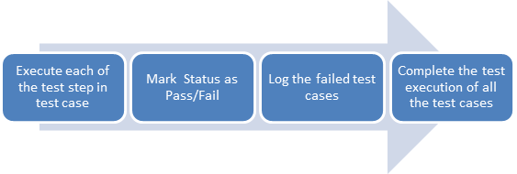

Testing will be focused on meeting the requirements (use cases) and evaluating the quality of the code and project itself. Testing processes will be well defined, yet flexible, with the ability to change as needed.

**Feedback.** Alpha and beta testing were not conducted. However, the plans have been created.

**Conclusion**

Although the project was not finalized, a lot of progress has been made. Various functionalities are working in the MVC application. Other tables and stored procedures have been implemented in the database but not in MVC. The team has created thorough documentation in order to transition the project to a new team. Since the project has a large scope, the team recommends to first become familiar with the ERD and MVC design.

The current group has spent weeks working on the ERD and finalizing it as much as possible in order to have a solid data model. Reflecting back on the work that was done for the project, the team wishes more time was allocated in order to create a solid MVC design plan as well. For more technical details to help understand the project, check the Technical Documentation document as well as the Testing Plan.

**Appendix A: SWOT Analysis**

|  |  |  |
| --- | --- | --- |
| **SWOT ANALYSIS** | | |
|  | **Opportunities** | **Threats** |
|  | Time management techniques and tools can be found online. | A sudden change in requirements (growth or shrinkage) can be a high risk for the project. |
|  | Online resources to conduct research (lynda.com, channel 9, Pluralsight, etc) will be available for the team. | Productivity issues and communication issues can be potential risks that can affect the project. |
|  | The system could be integrated to acquire information about credentials from EmpowerU and Banner if the project is successful. | The team does not have access to the DU Banner and WebFocus does not integrate well with DegreeWorks. |
|  | University-Wide expansion is one of the viable opportunities. Currently, our stakeholders do not manage the scheduling of Online or Health classes. In the future, the project can be tailored to include these classes as well. | There isn't very much input to work with; issues can arise when trying to figure out how to leverage what is already there to build the schedule. |
| **Strengths** | *S-O Strategies* | *S-T Strategies* |
| The individuals bring a variety of strengths to the team, such as: excellent problem solving, written/verbal communication skills, and excellent technical skills. | The team can apply their knowledge and skills to conduct research and create a project schedule and project plan to keep them on track. | In order to mitigate the risk of sudden change in requirements, the team will communicate frequently and concisely both internally and externally (with the stakeholders). |
| The project can potentially benefit the scheduling department as well as the University as a whole. | The project would overall make the credentialing and scheduling process more effective and benefit the University. | The team will communicate and coordinate in such a manner that the project will not be underestimated. The team will also conduct research to understand requirements and create a thorough design of the system before implementing it. |
| The project will be more functional. The current system is a physical drive (with various spreadsheets). |  |  |
| Another strength of the project is that it is an internal project which means the team will have access to resources on campus (computers, software) and they can easily conduct interviews and questionnaires with the stakeholders (Prof. Kowalczk, Ms. Koogler, Mr. Case, etc). |  |  |
| **Weaknesses** | *W-O Strategies* | *W-T Strategies* |
| There will be limited time to complete the product (10 weeks remaining). | The team can utilize efficient time management techniques to complete and finalize the product. | One of the more critical risks at the moment is a lack of understanding the requirements. The team plans on holding more meetings with stakeholders and redefining the purpose of the project in order to fully understand its nature. |
| Limited knowledge of MVC applications and database design is one of the team's weaknesses. | The team can conduct research using various websites, textbooks and other resources in order to expand their knowledge and become familiar with MVC and Database Design. | All of the weaknesses mentioned can potentially provide a vulnerability point for the threats. In order to mitigate the project risks, the team will conduct a more in-depth risk assessment and take the time to plan out the analysis and design of the system before implementing it. |
| Not seeing the "big picture" can be a critical weakness for the team. |  |  |
| The project is not currently "backed" by the IT department or the University. It is considered an academic project, not a "real-world" project. |  |  |

*Figure 2*.SWOT analysis constructed by Stefana Rusu.

**Appendix B: Relevant Figures**

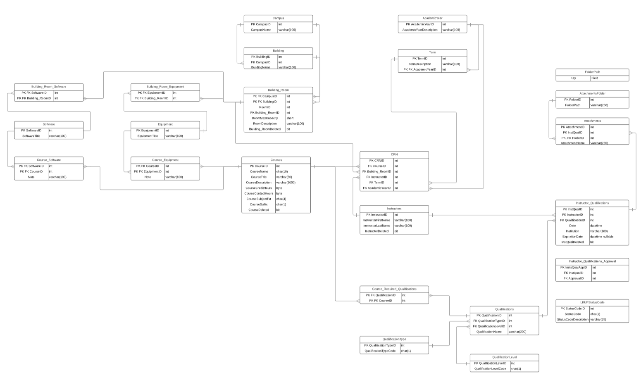

*Figure 1.* ERD

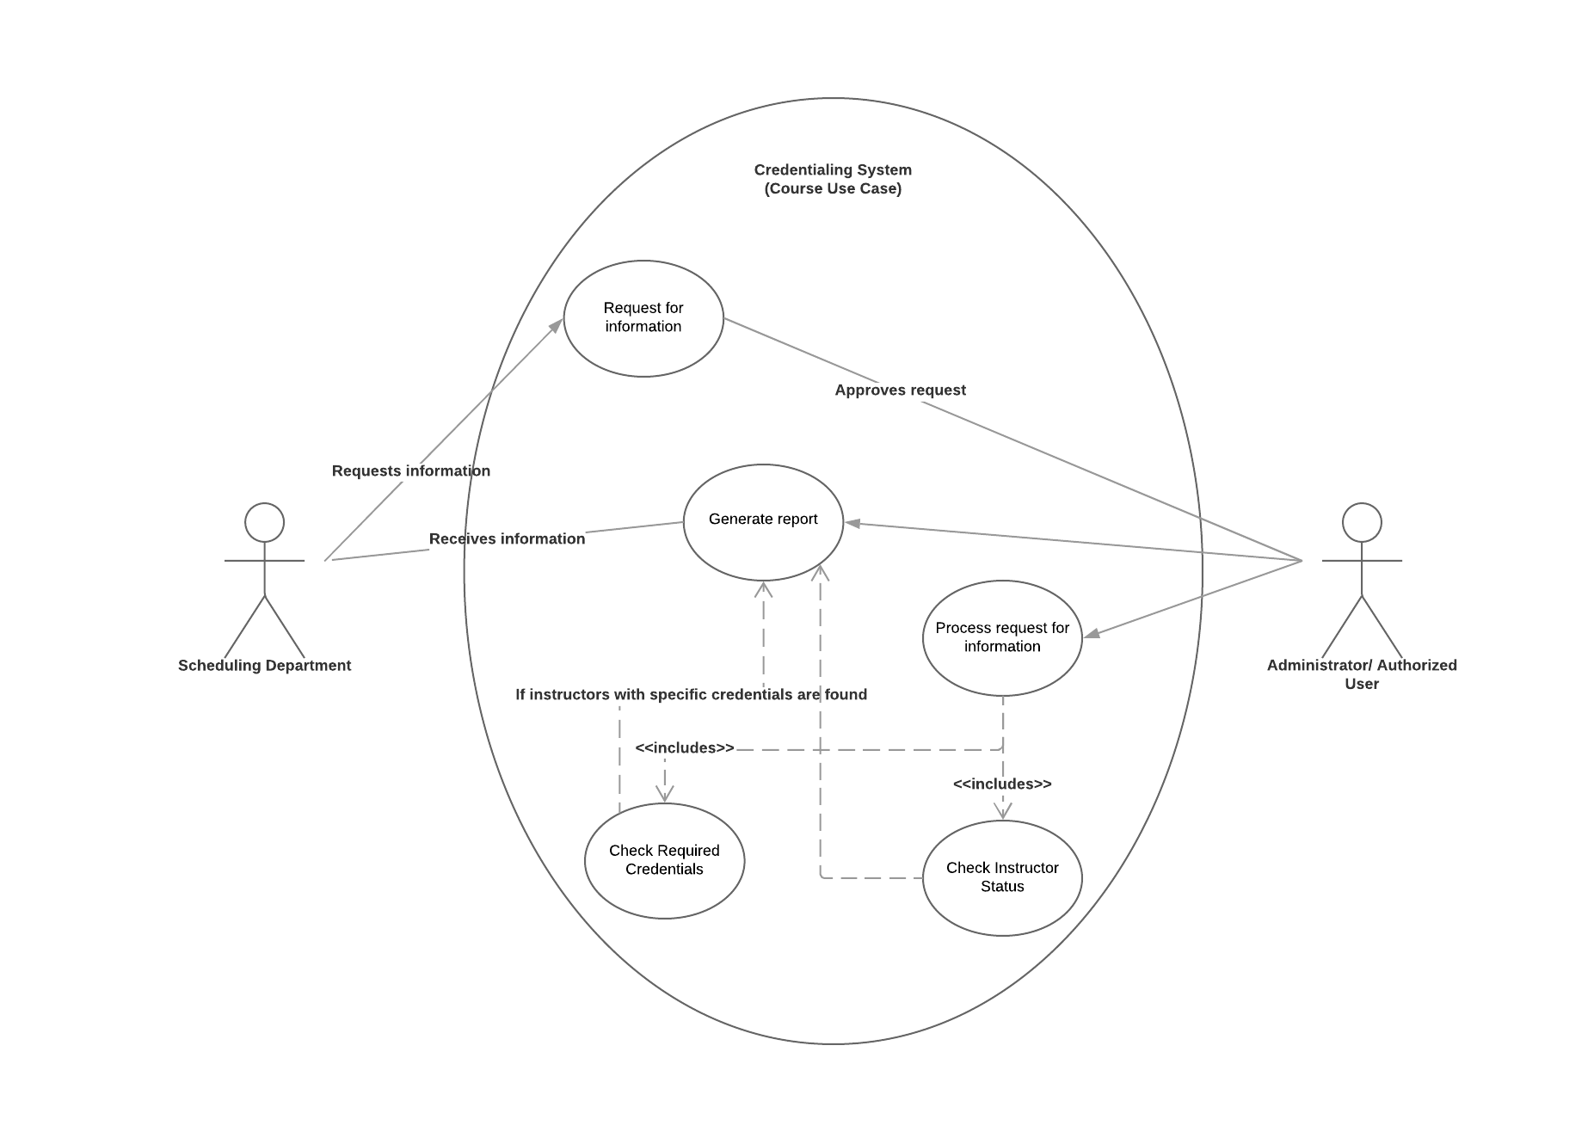

*Figure 2.* Use case for Courses. Which instructors can teach a specific course?

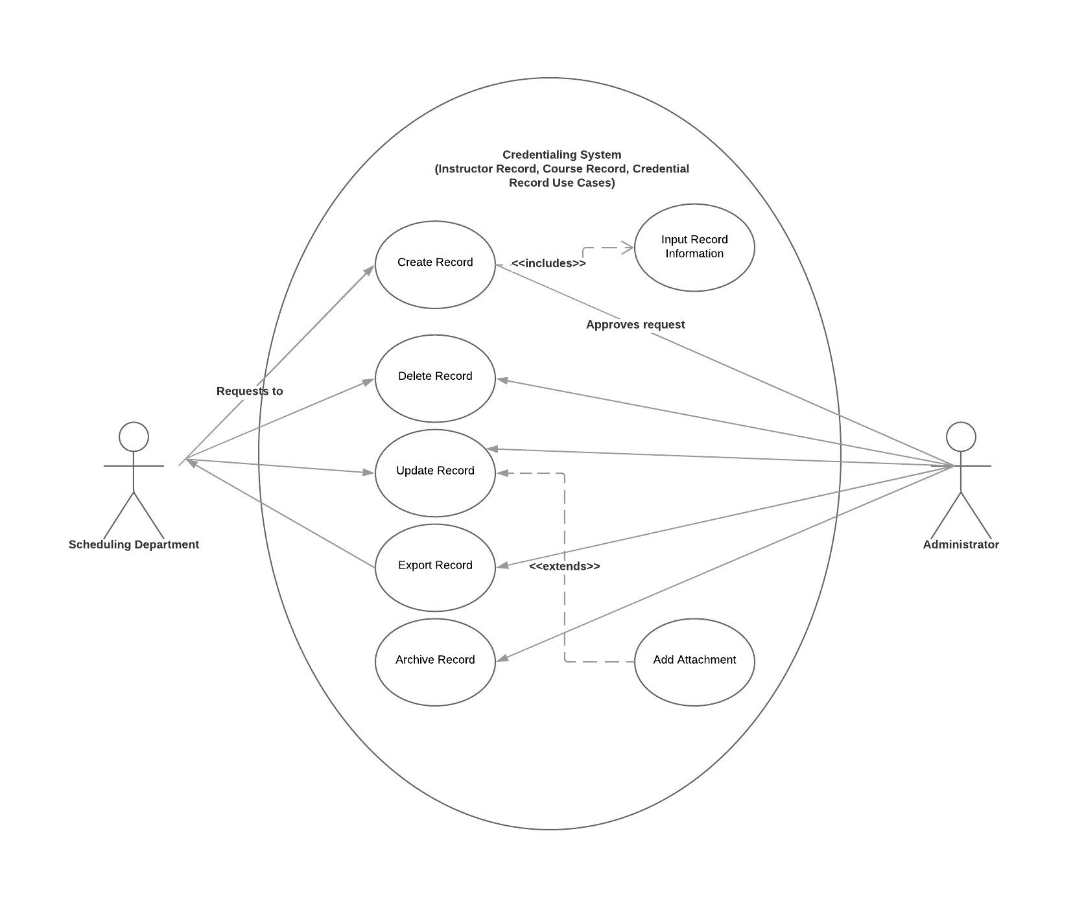

*Figure 3.* Use case for Records. Records include Credentials, Courses, Instructors, etc.

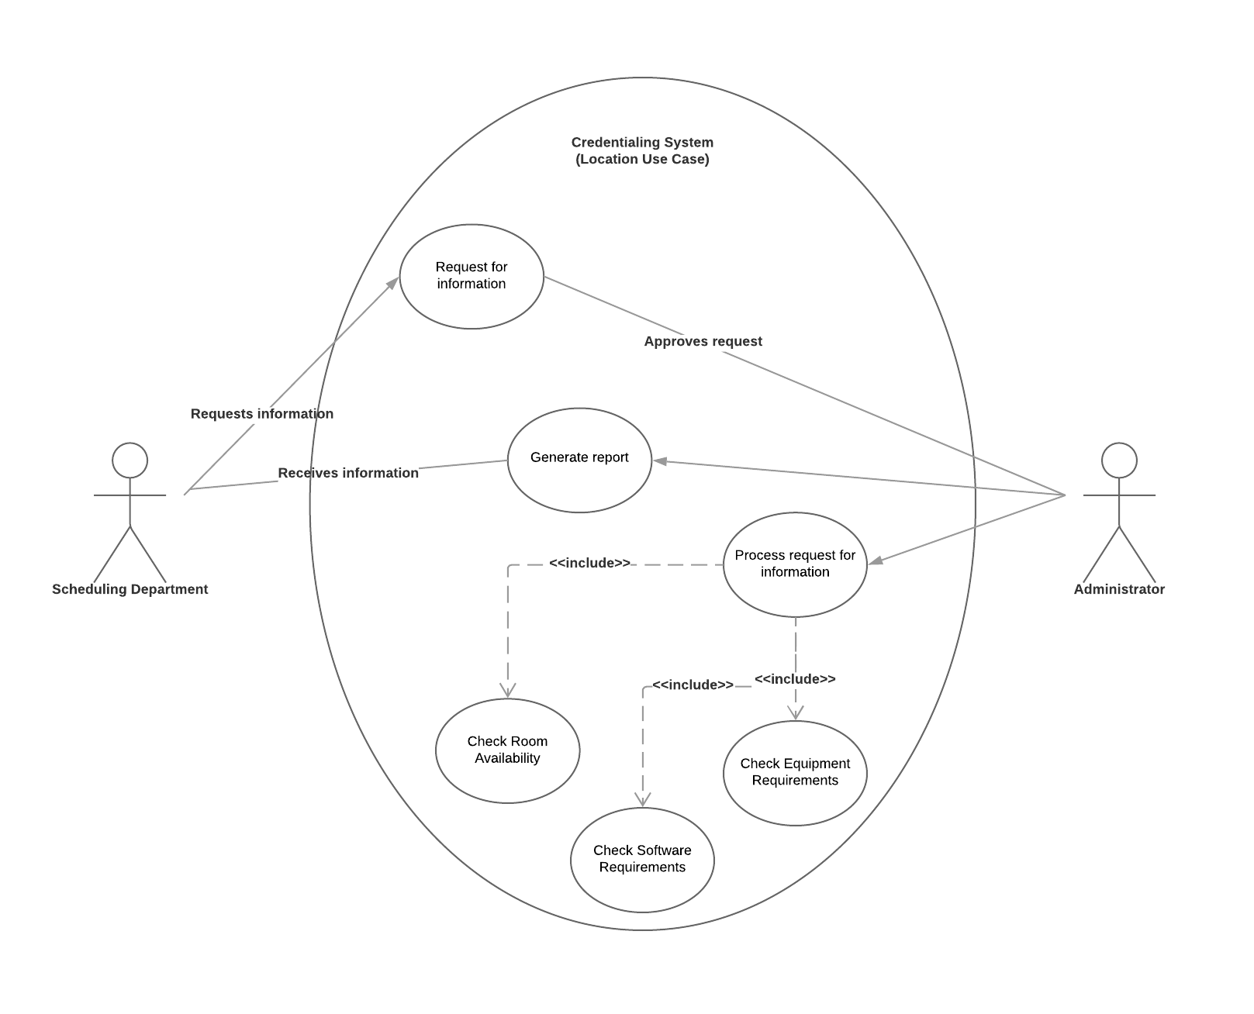

*Figure 4.* Use case for Room availability.